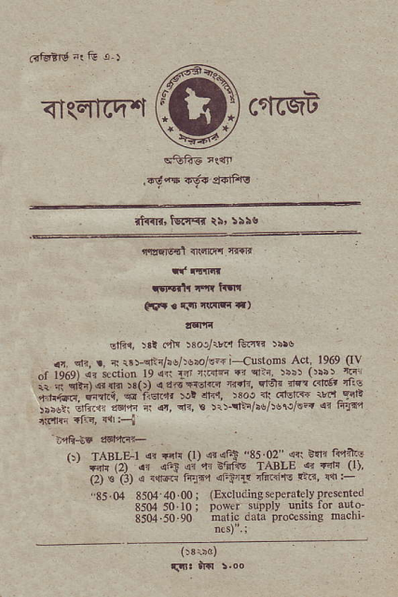
ffi
<Issrcq-'l cfrrqtr
I'GAE ,r:rr
,4€4s<ltr{ $dFle
it{rr{ tsc{<r _{ti,} :5ls
,nsr]ftl {l!|nf|r c.{r
tf rttld
_{wFrt!} :F.f t|trar
{+t . r|'l '{arr *)
. ^{qlFt{,} tsi d:]l uot*.'t ffltt :i5$
_{.r} ^{qri.} _{r} ? 1r:-d.4i!/:os/E-. i--{usoDs A.r. ¹⁹⁶⁹ 0\ _{^r ro^sr ir rcliob 19q,i r.} ^{'on} _{r?} ^{q:.} _{)bbr} (r:bi rF _{il i'crt{l} ^{q} _{r r(,r} ^{q} a.i -{ErG ri.F ra{ '14 dr6' 'Fs _{r"il;@.;qi.i',} @ riErlr )rt e', >3o1.t oft5@ r!d^gl't riiri. :r'ici. @,r ). _{.r,} ^{q.,} ! >l:-i-/i!/) 5 rJ ..{ <t FF
r_48+E ncf'tfi+
_{t:) TABLF?I} a. F{ _{(l)} ^{qt} {ci 85 02 ^{{{ RF ftri(! '} _{ffi,21 c{} ^{qr!} i r'r'nfis _{fAsLE} c FF (l). (2, ts _{(:J) 1 1!t;} ^{'njs"i 4} _{Fr1'} {Ahrs c'r{ 4{:-
"85.04 8504 40 00 ; (Excludingkperatelvp.e$tted ssoa 50 t0 _{i irower} supplv uils for tuto 8504 50 90 matic dala proce$utg rlacnl
nes).;
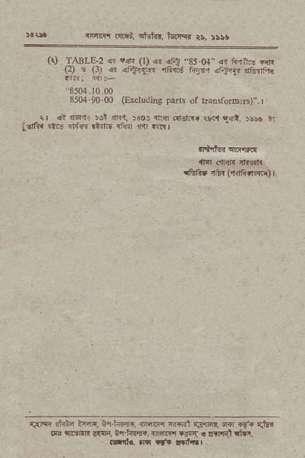
T,alEr _{nl.qi,} ^{qtuln,} llral' tt >rr.
^{(r)} TABLE-2 .d ?f{ (t) {r lFt.85.04 !{ lqttu ^{rrr|} .{2) € G) {r _{r'.!nT'} ^{q6< j} r4Id,r l4l?t' dtuf.rr
"8504.10.00
⁸⁵⁰⁴ 90 00 ^{(Exchdbg} !d!ts of rlalsforE 6)". I _{rr} q> rs'r' :c! 4"r, :so) ^{d:a.rttRr} rv.l ^{qart,} )bno t _{LEii{ .iu5} ^{qr!-F} _{{ir'.E} ^{qf{o} r{, .Ia,
_{flfttor} qrff.d
4m olElr .tl@tl
tlth5 16r ^{(lnfiirrr-r)} r.
{,aw ?fra t{n, Bn hny{, T.m.r.t clan'l r.6.fld, m 1v.+ {rrE _{dI} ^{qciqri} rcrri, i+hffq flwqr fjq . lrl'rft ctr,', !sd., 5In rf. rfirr .

